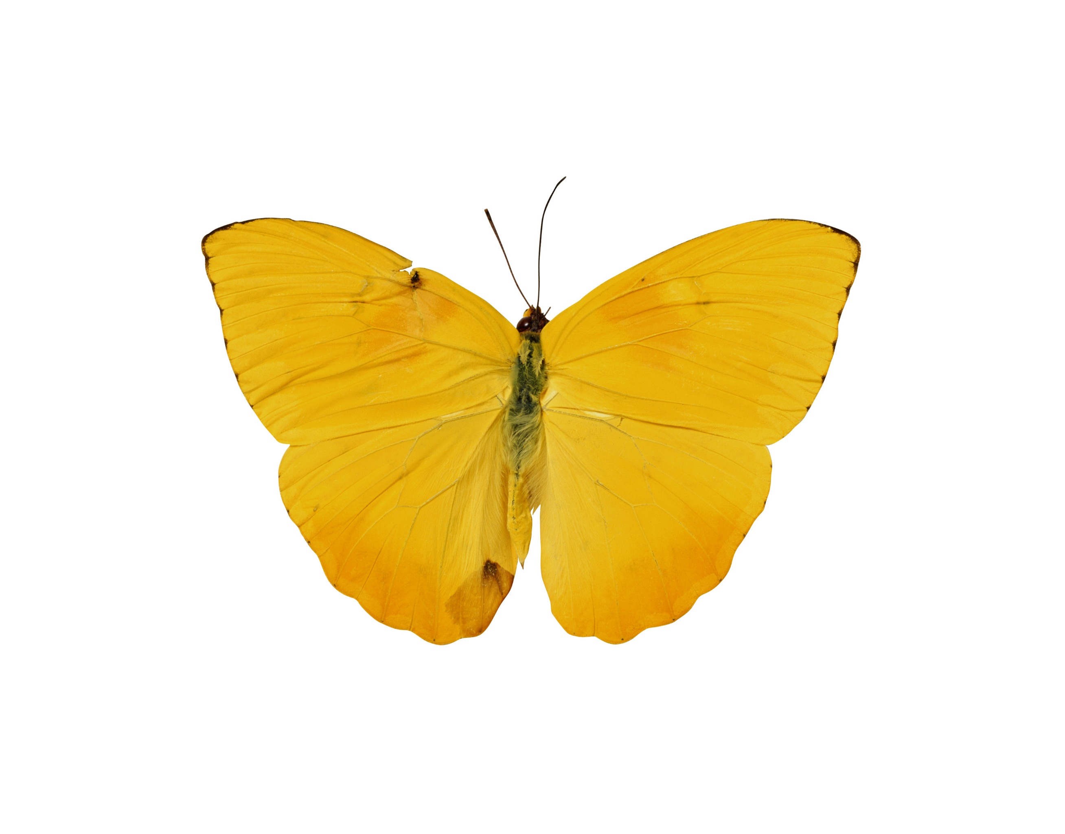

***Lioba M. Royal***  
***Club Coordinator***

**Awty’s Clubs and Honor Societies**

***Questionnaire for Honor Society   
  
Honor Society’s name: ________________________________________________________***

***Sponsor: _____________________________ E-mail: ___________________________***

***Vice sponsor: __________________________ E-mail: ____________________________***

***Founder: _____________________________ Founded: ___________________________***

***Description of the Honor Society’s purpose, goals, intentions (Please use the attached page to give a description of the Honor society you sponsor)***

***Which requirement(s) of CAS does this Honor Society fulfill?***

***Creativity Activity Service or Just fun ?***

xf

***How often does the H. S. meets? _________Time: _________ Location? __________***

***Are attendance notes taken at every meeting? Yes No***

***Who is taking attendance notes? _____________________________________________***

***How often do students have to attend the meetings to get credit for CAS classes?***

***_______________________________________________________________________***

***How many people are in the Honor society? _____________________________________***

***Are there different positions the students have (officer, treasurer)?***

***Please add each position with student’s name, grade, and time in the position.***

1. ***_________________________________________________________________***
2. ***_________________________________________________________________***
3. ***_________________________________________________________________***
4. ***_________________________________________________________________***

|  |  |  |
| --- | --- | --- |
| |  |  | | --- | --- | |  | ***Danke, Grazie,*** [**спаси́бо**](http://dict.leo.org/rude/index_de.html#/search=%D1%81%D0%BF%D0%B0%D1%81%D0%B8%CC%81%D0%B1%D0%BE&searchLoc=0&resultOrder=basic&multiwordShowSingle=on) ***Merci,*** 謝謝  ***Gracias,* مرسی.** धन् यवाद **Dankzij, 谢谢 Takket være, بفضل, Thank you** | |



***C o C***

***Description of the Honor Society’s Purpose, Goals, Intentions***

1. ***Purpose:***
2. ***Goals:***
3. ***Intentions:***

***Danke, Grazie,*** [**спаси́бо**](http://dict.leo.org/rude/index_de.html#/search=%D1%81%D0%BF%D0%B0%D1%81%D0%B8%CC%81%D0%B1%D0%BE&searchLoc=0&resultOrder=basic&multiwordShowSingle=on) ***Merci,*** 謝謝  ***Gracias,* مرسی.** धन् यवाद **Dankzij, 谢谢 Takket være, بفضل, Thank you  
*Merci,*** 謝謝  ***Gracias,* مرسی.** धन् यवाद **Dankzij, 谢谢 Takket være, بفضل, Thank you**